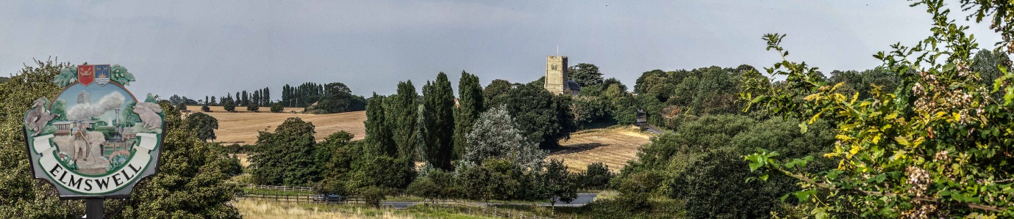

Elmswell Neighbourhood Plan
MINUTES
of the Steering Group meeting held on
22nd April at Elmswell Memorial Library
Present: Philip Blissett, Neil Brown, Julie Cole, Peter Dow, Peter Edmonds, Mary Feeney, Terry
Garner, Peter Goodridge, Sarah Mansel, Fred Pallett, Shaun Pratt, Ann Richards,
Jane Storey.
Attending: Gillian Benjamin
1. Apologies were received from Marian Abbott.
2. Minutes of the 2nd April were approved.
3. Peter Dow took the meeting through his notes from a recent Mid Suffolk seminar also attended by Gillian Benjamin.
4. Gillian Benjamin took the group through the process of drawing up a stakeholder analysis which exercise was tackled in several separate groups of members and the results taken away by Peter Dow for presentation in graphic form.
5. Gillian Benjamin tabled a draft Project Plan which Peter Dow undertook to distribute by email for comment.
6. It was agreed that the Parish Council be asked to build the forthcoming Annual Parish Meeting around the Neighbourhood Plan Project, date yet to be advised.
7. Peter Goodridge and Julie Cole are to pursue the social networking / website options via Vince Woodward.
8. The next meeting was to review submissions made by Peter Dow regarding, ‘Issues’, and to firm-up on the stakeholder analysis. A schedule of possible visits to village groups to explain and take forward the Plan might be appropriate.
9. The meeting finished at 9.05pm.
Peter Dow

